Experiment 6

**Implementing Simple servlet in java**

Name: Sai Harsha Vardhan AVN

Roll-no: BCSE1823

Batch: ‘A’

**Aim**: Write a program that implement a simple servlet

**Theory:**

Servlets are Java classes which service HTTP requests and implement the **javax.servlet.Servlet** interface. Web application developers typically write servlets that extend javax.servlet.http.HttpServlet, an abstract class that implements the Servlet interface and is specially designed to handle HTTP requests.

Steps to create a servlet example

There are given 6 steps to create a **servlet example**. These steps are required for all the servers.

The servlet example can be created by three ways:

1. By implementing Servlet interface,
2. By inheriting GenericServlet class, (or)
3. By inheriting HttpServlet class

The mostly used approach is by extending HttpServlet because it provides http request specific method such as doGet(), doPost(), doHead() etc.

There are few server’s to run your application , you can use either of those for example we have **apache tomcat server, Glassfishserver etc**. The steps are as follows:

1. Create a directory structure
2. Create a Servlet
3. Compile the Servlet
4. Create a deployment descriptor
5. Start the server and deploy the project
6. Access the servlet

Directory/File Structure for Servlet Programs to run is shown below:

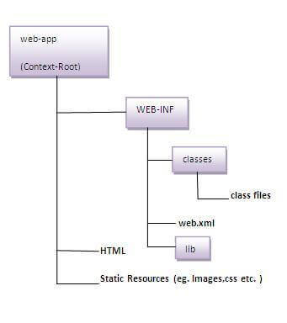

**Code**:

1. ***Web.xml Code***:

<?xml version="1.0" encoding="UTF-8"?>

<web-app version="3.1" xmlns="http://xmlns.jcp.org/xml/ns/javaee" xmlns:xsi="http://www.w3.org/2001/XMLSchema-instance" xsi:schemaLocation="http://xmlns.jcp.org/xml/ns/javaee http://xmlns.jcp.org/xml/ns/javaee/web-app_3_1.xsd">

<servlet>

<servlet-name>details</servlet-name>

<servlet-class>details</servlet-class>

</servlet>

<servlet-mapping>

<servlet-name>details</servlet-name>

<url-pattern>/details</url-pattern>

</servlet-mapping>

<session-config>

<session-timeout>

30

</session-timeout>

</session-config>

</web-app>

1. ***Index.html Code***:

<html>

<head>

<title>TODO supply a title</title>

<meta charset="UTF-8">

<meta name="viewport" content="width=device-width, initial-scale=1.0">

</head>

<body>

<form action="details" method="get">

First Name:<input type="text" name="n1"> <br> <br>

Last Name:<input type="text" name="n2"> <br> <br>

Email-Id:<input type="email" name="n3"> <br> <br>

Phone-Number:<input type="tel" name="n4"> <br> <br>

<input type="submit" name="btn1" value="Submit">

</form>

</body>

</html>

1. Top of Form
2. Bottom of Form
3. Top of Form
4. ***Details.java Code*:**

import java.io.IOException;

import java.io.PrintWriter;

import javax.servlet.ServletException;

import javax.servlet.http.HttpServlet;

import javax.servlet.http.HttpServletRequest;

import javax.servlet.http.HttpServletResponse;

public class details extends HttpServlet {

@Override

public void doGet(HttpServletRequest req, HttpServletResponse resp)

throws ServletException, IOException {

System.out.println("doGet");

resp.setContentType("text/html");

PrintWriter out = resp.getWriter();

out.println("<html><h1>It works!!</h1></html>");

String name,lastname,email,phono;

name = req.getParameter("n1");

lastname = req.getParameter("n2");

email = req.getParameter("n3");

phono = req.getParameter("n4");

//System.out.println("name\n"+name+"Last Name:\n"+lastname+"email:\n"+email+"Phone-Number:\n"+phono);

out.println("<html><h1>"+"First Name:<br>"+name+"<br>"+"Last Name:<br>"+lastname+"<br>"+"email:<br>"+email+"<br>"+"Phone-Number:<br>"+phono+"</h1></html>");

}

}

**Output:**

1. Web Page:

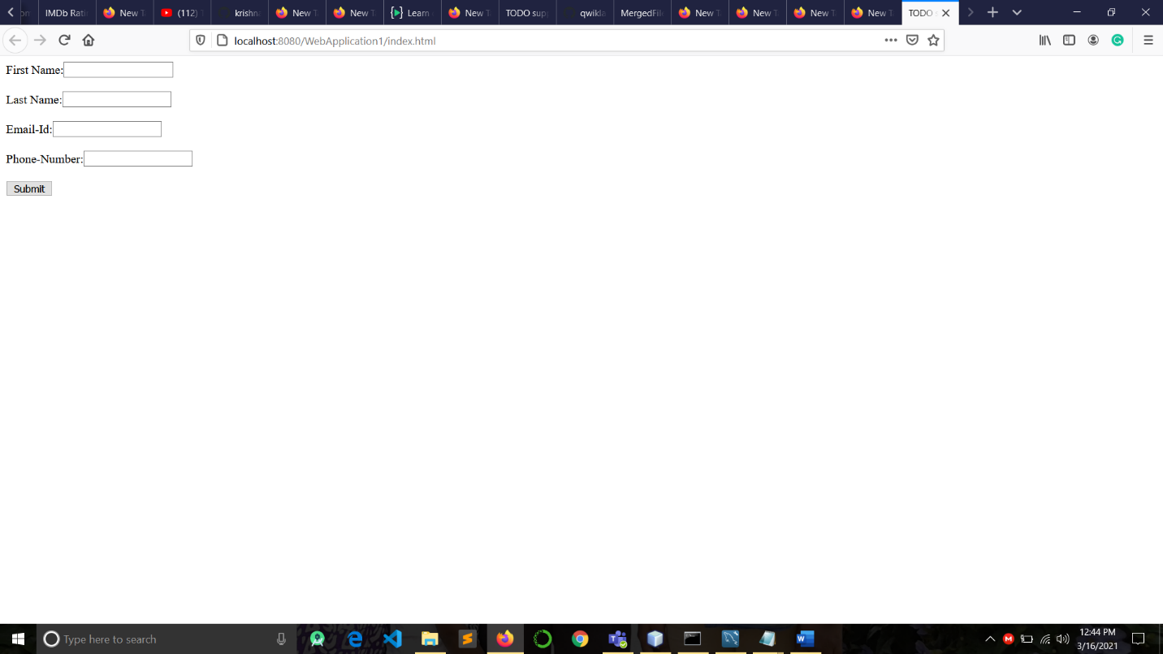

1. After Submitting the Details

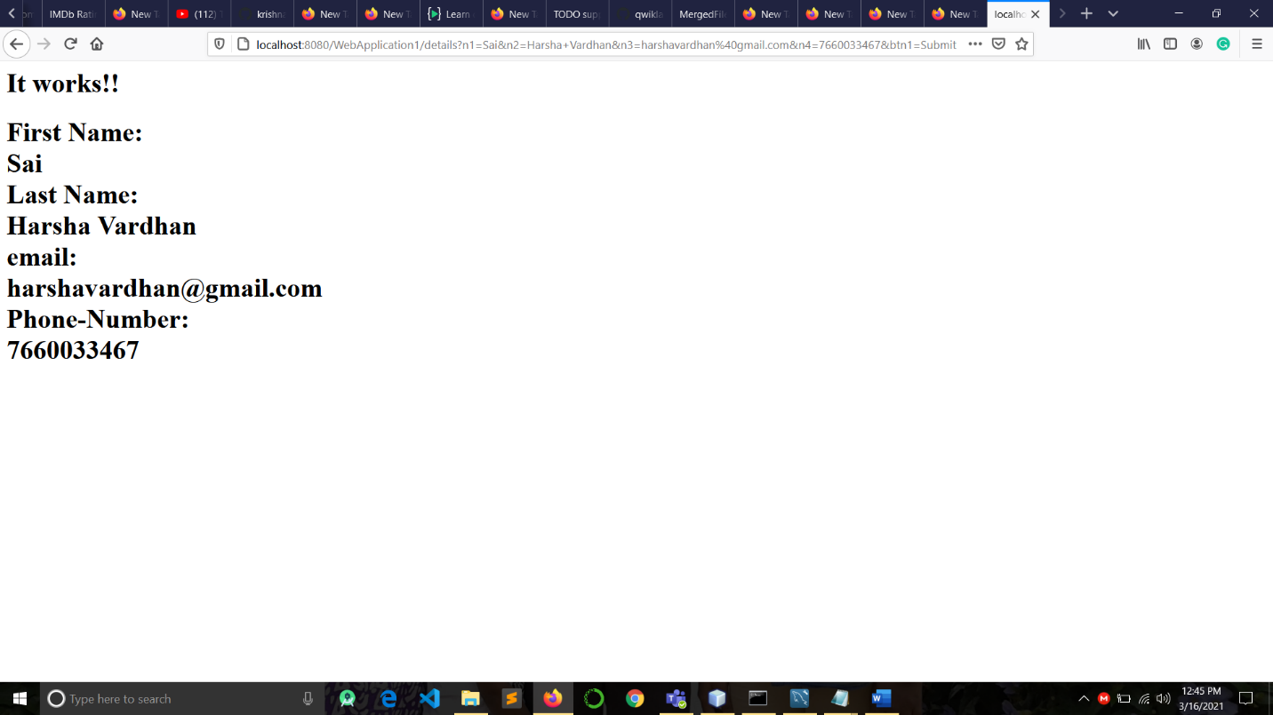

1. Inside the Glassfish-server:

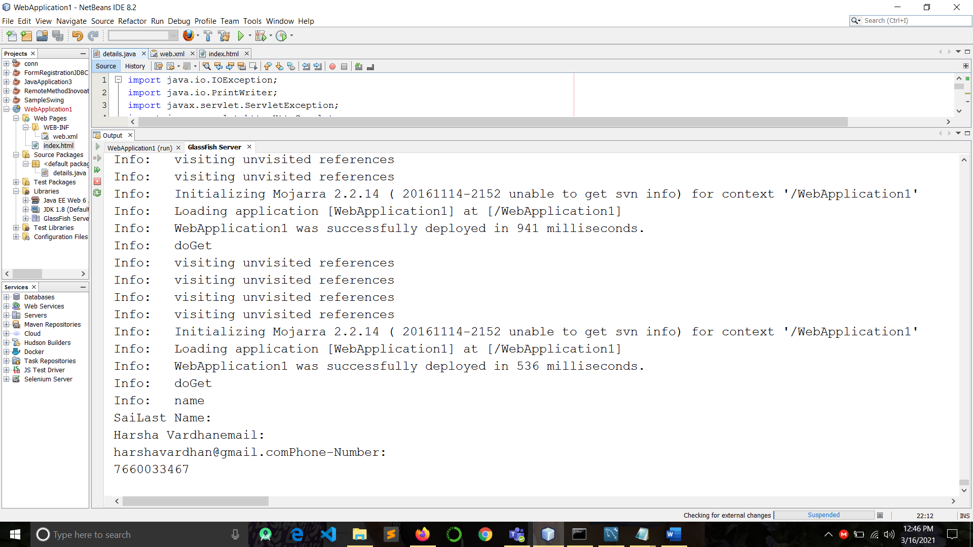

**Conclusion**: The Simple servlet Program in java is implemented successfully.